Name:

UTD MIDTERM EXAM

MIS: Cyber Security Fundamentals

*** PLEASE READ AND FOLLOW INSTRUCTIONS CAREFULLY ***

ANSWER A TOTAL OF 20 QUESTIONS BELOW.
- This is open book. You may use any source as long as you cite the source.
- You may use the materials from the class, Internet, or other sources.
- Cite your source in simple format – (e.g. “http://...”, “Class slides”, etc.)
- Please write your answers directly inline inside this word document.

EMAIL EXAM TO: cmd140430@utdallas.edu

*** IMPORTANT NOTE ON EXAM INTEGRITY ***

Please do not share this exam with other students. Your choice to preserve the integrity of this exam helps ensure others get the opportunity to have the same testing experience.

This Midterm Exam Covers the Following Topics:
- MIS 6311-501 Session 01 - Course Overview
- MIS 6311-501 Session 02 - Access
- MIS 6311-501 Session 03 - Network
- MIS 6311-501 Session 04 - GRC
- MIS 6311-501 Session 05 - Development
- MIS 6311-501 Session 06 - Cryptography

About the Midterm Exam:
The purpose of this exam is to give you real life questions and business problems encountered every day during the professional application of information security and risk management to world-class organizations.
The learning process does not stop after the lectures. Given the foundational base of the course information, I encourage you to spend the next few hours pulling this information together as you answer these questions.
Your achievable and realistic objective in this course is to learn enough to remember some details, and look the rest up. This is how I exercise my job every day, and why I feel this exam is the most appropriate means for testing your knowledge. Good luck!

What to do if you find a question that covers material you haven’t seen before?
1. Research and provide a reasonable answer… or…
2. Skip and answer another question. There are plenty to choose from.

SECTION A: First half of the course.
- MUST ANSWER: Explain the relationship between the 5 elements below. We did this multiple ways, and there are several acceptable answers. I want to know that you can think through each of the following. Use your own words!
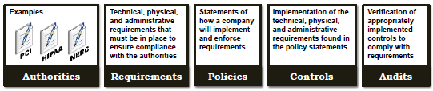
- MUST ANSWER: Explain what we reinforced by showing the Porter Value Chain at the end of every class. You can either explain in your own words, or use the 3 simple statements.
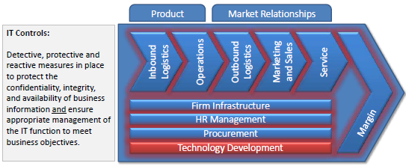
- What are the forms of multi-factor authentication (hint.. there are three)
- What is the purpose of an IPS?
- What does AAA stand for? Define each with an example.
- What are the components of the CIA Triad? Define them.
- Security programs have goals. Explain 3 types of goals.
- Who is ultimately responsible for an organizations security? There could be more than one answer to this question, depending on how it is that you defend your answer.
- What is the difference between a vulnerability, threat, and exposure?
- What are the goals of (specifically…) Risk ANALYSIS. (Hint. Answer has five bullets.)
- What is SLE? What is the formula for SLE? Please spell everything out…
- Explain an example of a Qualitative Risk method.
- What is the difference between the security policy, standard, and baseline?
- What is the difference between a data owner and data custodian?
- What is the importance of individual separation of duties?
- Notice that the Reference Monitor is an abstract or conceptual idea. It is used to discuss the interaction between the five components below. Fill in the blanks below using the words in the blue boxes. The first one is done for you.
  - The ultimate goal is to define and control using a repository of subject and object security attributes (__ authorization database __)
  - the access of active entities, users, and processes (????????)
  - to files, directories, data or services ((????????))
  - based on situational context ((????????))
  - and record security related events ((????????))
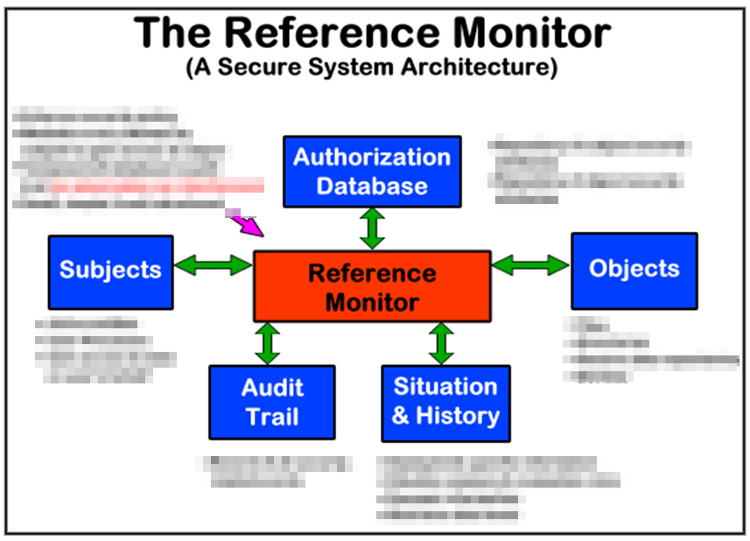
- Why is penetration testing different from vulnerability testing and why is it important?
- What is a protocol and what is data encapsulation?
- What is the difference between TCP and UDP connections?
- Traditionally, name 5 differences between circuit switching and packet switching as discussed in the class.
- Using descriptions discussed in the class, describe the differences between layers 2 and 3 of the OSI model.
- What is the difference between multi-home firewalls and screened subnets?
- Provide three examples each for Technical, Physical, and Administrative controls.
- We mentioned common technical controls in relation to a solutions crosswalk. The first example was in a portion of the presentation I presented to the RSA conference in London and had 18 specific controls. Why do we care about this? What is the significance of having this control set addressed?
- We do not spend a lot of time on the difference between ISO27001, and iso-27,002. Either in the slides or online, find the difference and explain it.
- What is the result from assessing risk? Simple question. Many answers. The most concise answer I’ve seen is from the atsec ISO 27,000 program overview that we covered in session 3.
- It doesn’t get any easier than this. Information is beautiful. Using any measure you would like, name and quantify 3 large breaches in the last 10 years. Because of how the question is worded, there are many answers.
- Identify 5 real-world problems with access controls. Why is it difficult?
- Define access controls.
- What is the crossover error rate? Do not overthink this one.
- Describe what each of the following measure:
  - Fingerprint –
  - Hand topology –
  - Hand geometry –
  - Retina Scan –
  - Iris scan –
- How does an asynchronous one time password work?
- What is the difference between mandatory and discretionary access controls? This answer can be as simple or complicated as you would like.. You can use text or a picture.
- Find a description of the 7 layers of the OSI model. Explain the primary difference between transport and network layers.
- What is the difference between liability, connection, and packet sequencing between TCP and UDP?
- What is a network socket?
- What is the difference between background noise and attenuation?
- What is the difference between CSMA/CD and CSMA/CA?
- What is the difference between an application level proxy, circuit level proxy, and kernel proxy?
- Find from any source and describe 3 different forms of Bluetooth attacks.
- What is the purpose of defense in depth?
- What is the difference between risk and a control?
- What are 2 other names for “control”?
- What are 5 differences between quantitative and qualitative risk management?
- Two specific sites covered key considerations for the “functionality and effectiveness of countermeasures”. Identify what you consider to be the most important characteristic and explain why. There are multiple answers. You simply need to defend yours.
- If you have effectively enforced separation of duties inside an organization, then to subvert controls you may have to have collusion. Describe collusion.
- What is the difference between verification and validation?

